Problem: A
Task 1. Write a MATLAB code that reads a gray scale image and generates the flipped image of original image. Your output should be like the one given in Figure 1

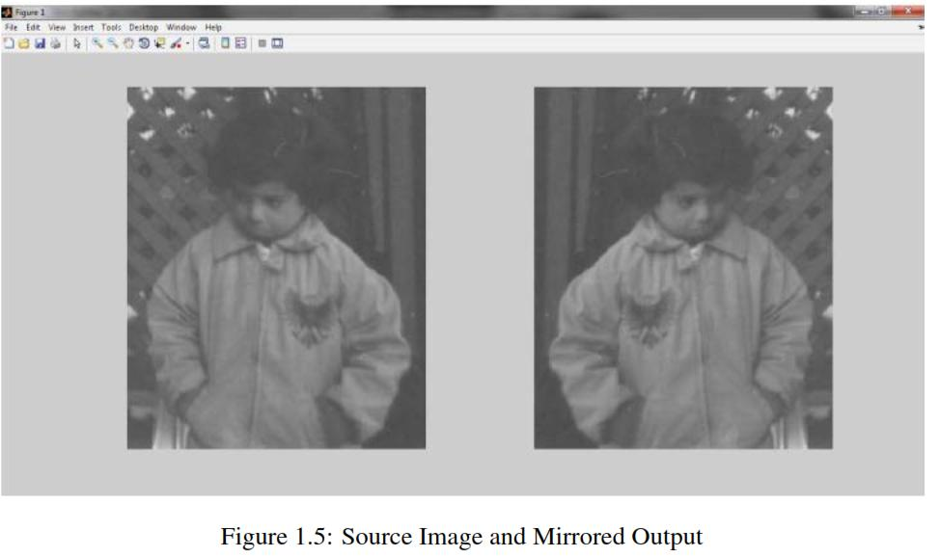

Task 2. Write a MATLAB code that will do the following:
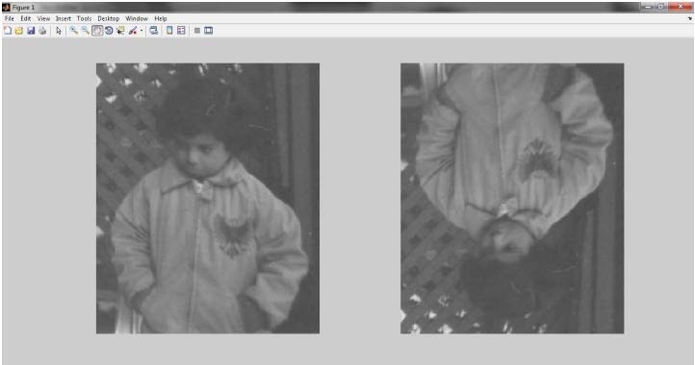
Figure 1: Source Image with Desired Output

Problem: B
- Read any gray scale image.

- Display that image.

- Again display the image such that the pixels having intensity values below than 50 will display as black and pixels having intensity values above than 150 will display as white. And the pixels between these will display as it is.

Problem: C
Task 1. Reducing the Number of Gray Levels in an Image Write a computer program capable of reducing the number of gray levels in a image from 256 to 2, in integer powers of 2. The desired number of gray levels needs to be a variable input to your program.
Task 2. Zooming and Shrinking Images by Nearest Neighbor Write a computer program capable of zooming and shrinking an image by nearest neighbor algorithm. Assume that the desired zoom/shrink factors are integers. You may ignore aliasing effects.
Task 3. Zooming and Shrinking Images by Bilinear Interpolation Write a computer program capable of zooming and shrinking an image by bilinear interpolation. The input to your program is the desired size of the resulting image in the horizontal and vertical direction. You may ignore aliasing effects.
Task 4. Write a program to find the sets of connected component in binary image based on 4-adjacent neighbors.

Task 5. Write a program to find the sets of connected component in a binary image based on 8-adjacent neighbors.

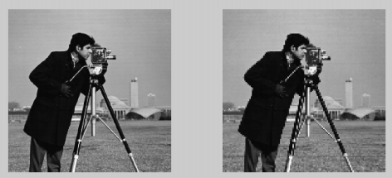
Figure 2: Source Image with Desired Output

NOTE:

Binary images can be created in mspaint or any other tool of your choice

Problem: D

Task 1. Implement negation transform.

Task 2. Implement Logarithmic transform.

Task 3. Implement Power-Law transform.

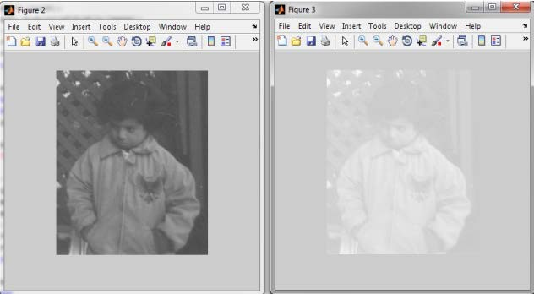

Figure 3: Power-Law Transformation with γ < 1
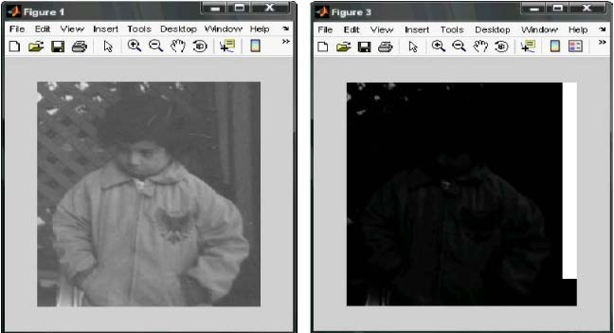
Figure 3: Power-Law Transformation with γ > 1

Problem: E
Median filtering works well for impulse noise but performs poor for Gaussian noise.

Task 1. Write a program to implement Smoothing Spatial filter and note the effects on given images.

Task 2. Write a program to implement order statistics filters and write down your observations.

Task 3. Run min, max, median filters on noisy images and notice the output

Task 4. Run average and Gaussian filters on noisy images and notice the differences.

Task 5. Write a code from scratch which will take an image and a kernel and run convolution

Task 6. Try to perform template matching using your convolution code.

Problem: F
- Write a program to read an image from a file and implement the following transformations of the image:
Task 1. Write a program to implement dilation and note the effect on binary images
Task 2. Write a program to implement erosion and note the effect on binary images
Task 3. Write a program to implement opening and note the effect on binary images
A ◦ B = (A B) ⊕ B
Task 4. Write a program to implement closing and note the effect on binary images
A • B = (A ⊕ B) B

SAMPLE INPUT/OUTPUT:
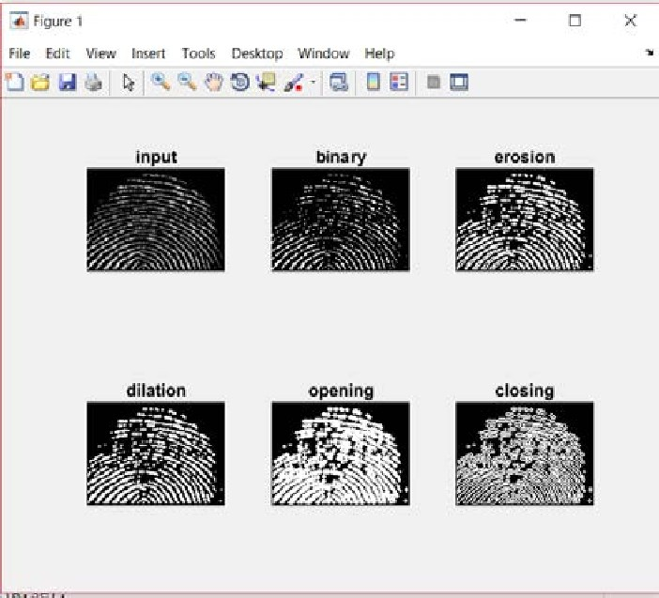

Figure 5: Original images and morphologically operated images.

Problem: G

Task 1. Write a program to implement “Sobel Gradient Operator” and observe the changes on image.

Task 2. Write a program to implement “Laplacian Operator” and observe the changes on image.

Task 3. Write a program to implement which will take an input image and an edge detection mask. It should return the edge-detected image.
Task 4. Write a program which will take the input image and return the output image as shown in Figure 6

SAMPLE INPUT/OUTPUT:

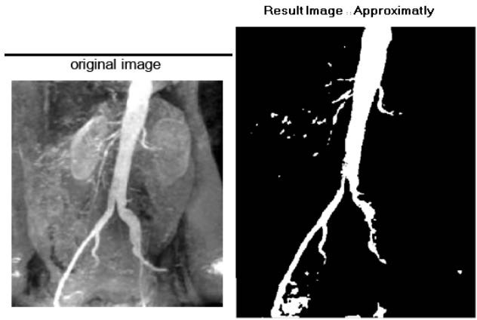
Figure 6: Original image and approximated binary edge directed image

